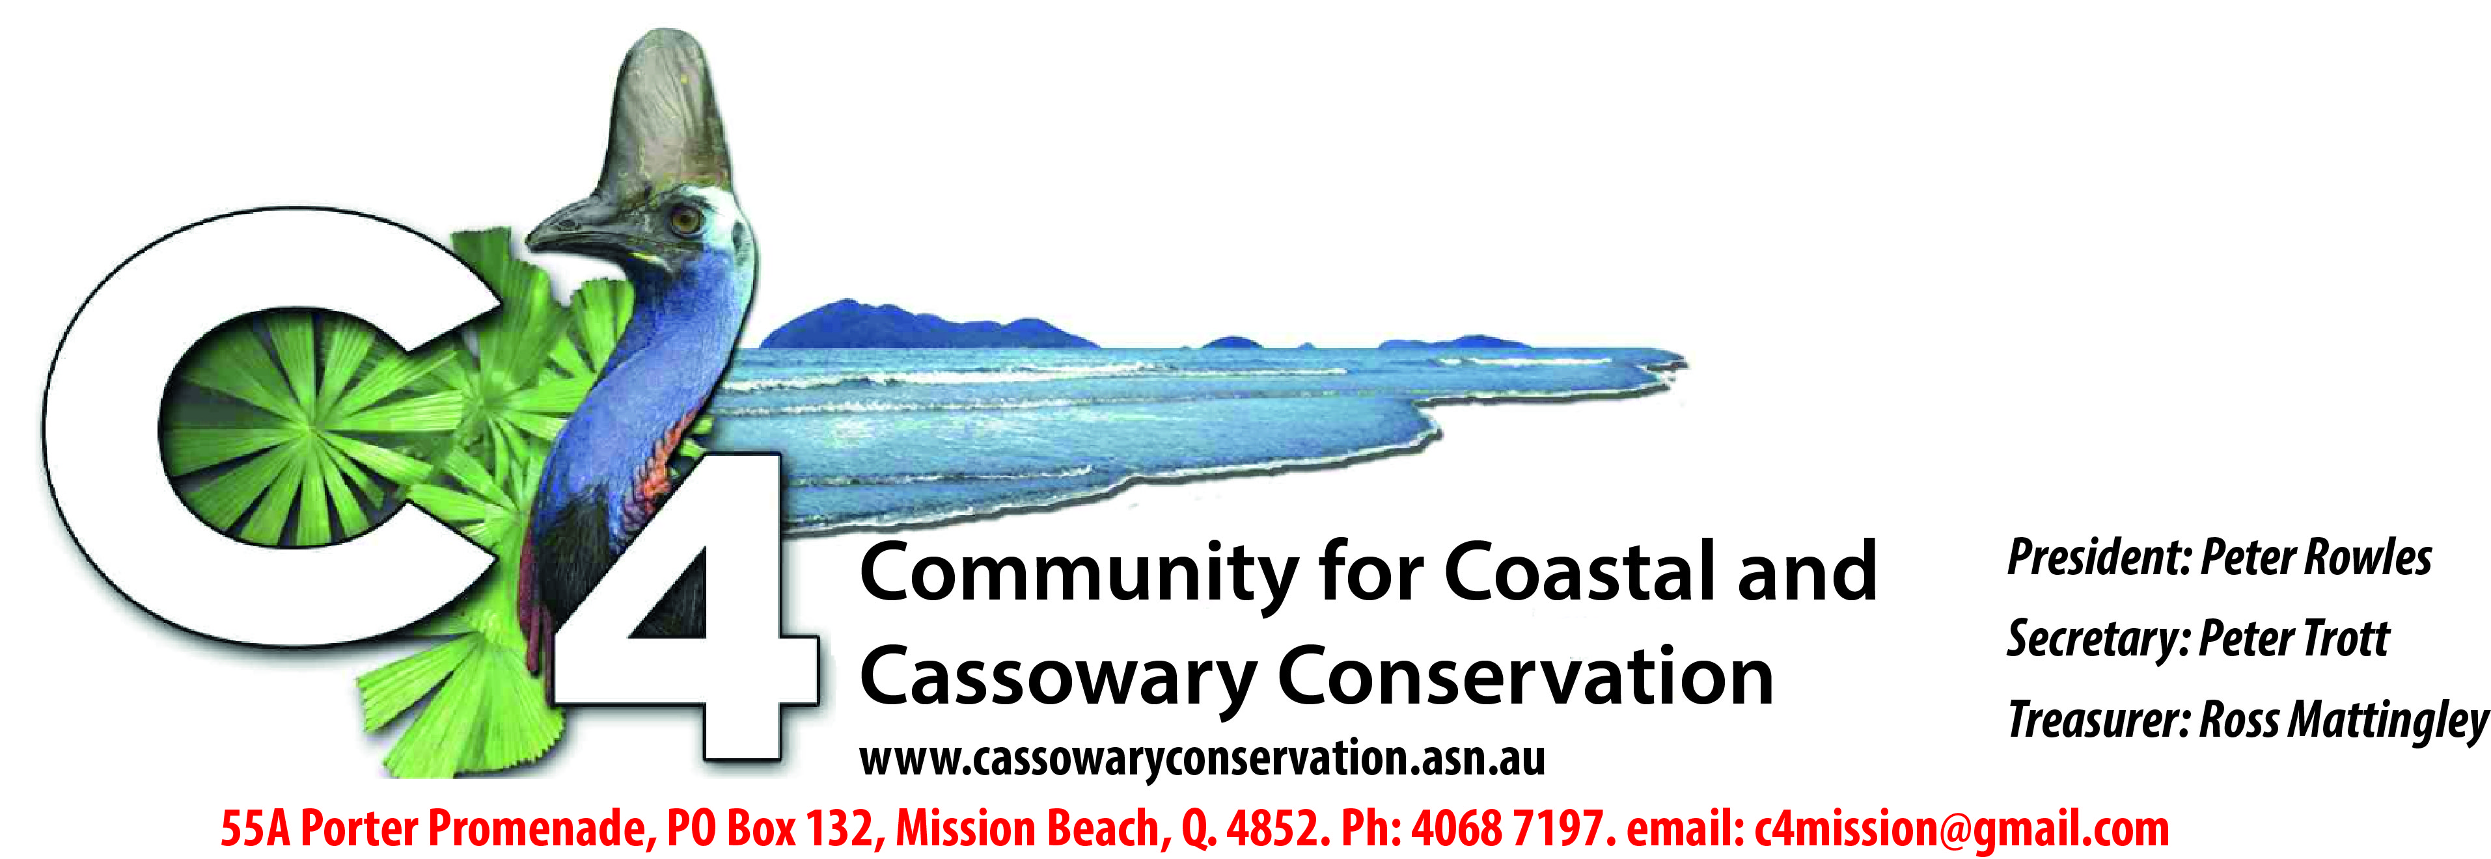

MEDIA RELEASE
February 28, 2022
COMPROMISE REACHED ON BEACH HELIPORT
A year-long battle over a helicopter base proposed for Mission Beach ended today (Monday February 28) with a settlement in the Cairns Planning and Environment Court between Community for Coastal and Cassowary Conservation (C4), Cassowary Coast Regional Council and Mission Helicopters.
C4 had appealed against the council's approval of a development application by Mission Helicopters to establish a helicopter base on rural land separating residential areas at Mission Beach.
A review of the case before Judge Dean Morzone confirmed that the appeal had been resolved in accordance with the terms of a consent order.
The new conditions agreed under the settlement put limits on the size of helicopters, operating frequency, noise creation and stored fuel, and exclude flight training and engine maintenance.
There are also changes to fencing, vegetation and other provisions.
C4 President Peter Rowles said: “We were not able to stop the helicopter base altogether but we were able to secure some more favourable conditions governing its operation than those the council saw fit to impose despite widespread community opposition.”
The council's approval in January 2021 of the application for a Material Change of Use from rural to air services sparked a groundswell of opposition.
C4 then sought legal advice and lodged an appeal through the Planning and Environment Court in March.
This included detailed examination of the initial development application, calling expert witnesses, including environmental, planning and acoustic experts, and preparing material for the appeal.
C4's submissions outlined that there was no evidence of need for the facility, that alternatives (Tully and Mundoo airports) were available nearby and that the operation of helicopters would impact on the amenity of residents and potential tourists who sought the environmental tranquility of Mission Beach.
It was also likely to impact on wildlife, including cassowaries in the nearby ‘Garrett Corridor’, which links coastal wetland habitat to protected National Park forests in Australia's longest east-west rainforest corridor.
“Regrettably, due to the non-specificity of the planning legislation and council's approach, advice from experts indicated that our arguments were unlikely to be successful in a legal battle,” Mr Rowles said.
“The bottom line is that continued court action was unlikely to result in the blocking of the project or further concessions from the developer. In view of the considerable expenditure required and the improbability of a better outcome, C4 could not justify continuing the appeal.
“More than a year after the initial approval, a mediated settlement has been reached, which is significantly better for the community and the environment than the original approval. It has locked in conditions which could well have been lost if the objection was sustained through an unsuccessful court action.
“One major realisation is that the CCRC Planning Scheme needs to be strengthened if the community wants to be better protected against future development in inappropriate locations.
"The C4 Management Committee thanks everyone who has helped with time, materials and donations through the Heliport appeal process.”
(ends)

For interview or more information please call Peter Rowles 0429179152
Issued by Community for Coastal and Cassowary Conservation
Secretary Peter Trott, 0407966965

