CASSOWARY FACTS FILE

Feathers: each feather has a Wings: Greatly reduced to only
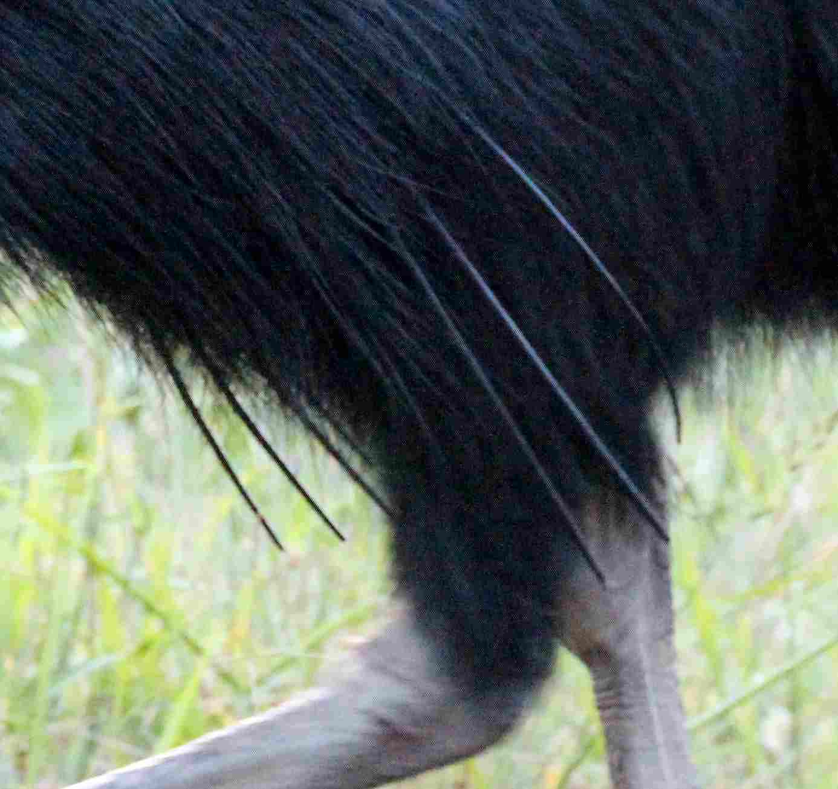
double shaft, giving it a coarse rudimentary stubs. Have 5-6
hair-like appearance. hollow quills.
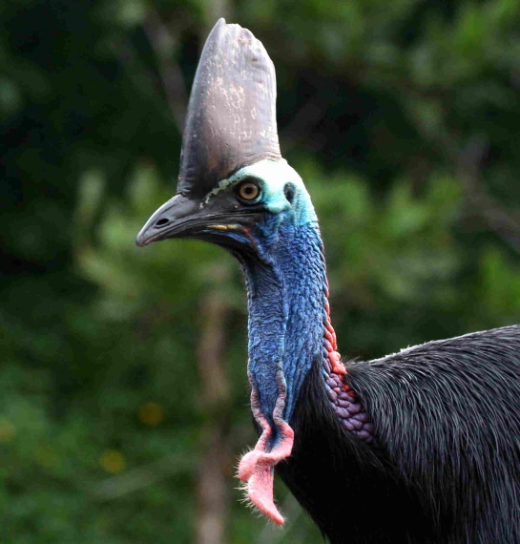

CALENDAR
January February March
Adult males seen with large young. Solitary females. Birds roam extensively due to forest fruiting period. Birds may eat insects, snails, rats, snakes and small dead animals, bracket fungi, even dirt (to fill stomach) and dried old droppings.

April May June
April and May are still difficult times for birds. Adult birds begin courting in May/June. Young are evicted from home ranges. This is a trying time for immature birds learning to fend for themselves in competition with intolerant breeding adults. Many juveniles succumb during this period.

July August September
More reliable fruiting in lowland with many favoured species in full fruit. Eggs (incubated 48-54 days) hatch during this maximum fruiting period. Males are very protective of chicks. Human contact should be avoided.

October November December
Males with striped/brown young a common sight. Solitary larger more colourful females make cameo appearances. No shortage of food. Very important period – birds build up reserves to cope with inevitable shortages in the new year.

Casque: or helmet has tough
Keratinous skin covering a
core of firm cellular foam. Longitudinally
it is rigid but can be squeezed from the
sides.

Wattles: are extended skin growths
that are present from birth (rudimentary).
They grow and turn from pink to red with
age.

Legs: Are stout and very powerful. If
provoked can deliver a karate-like kick.
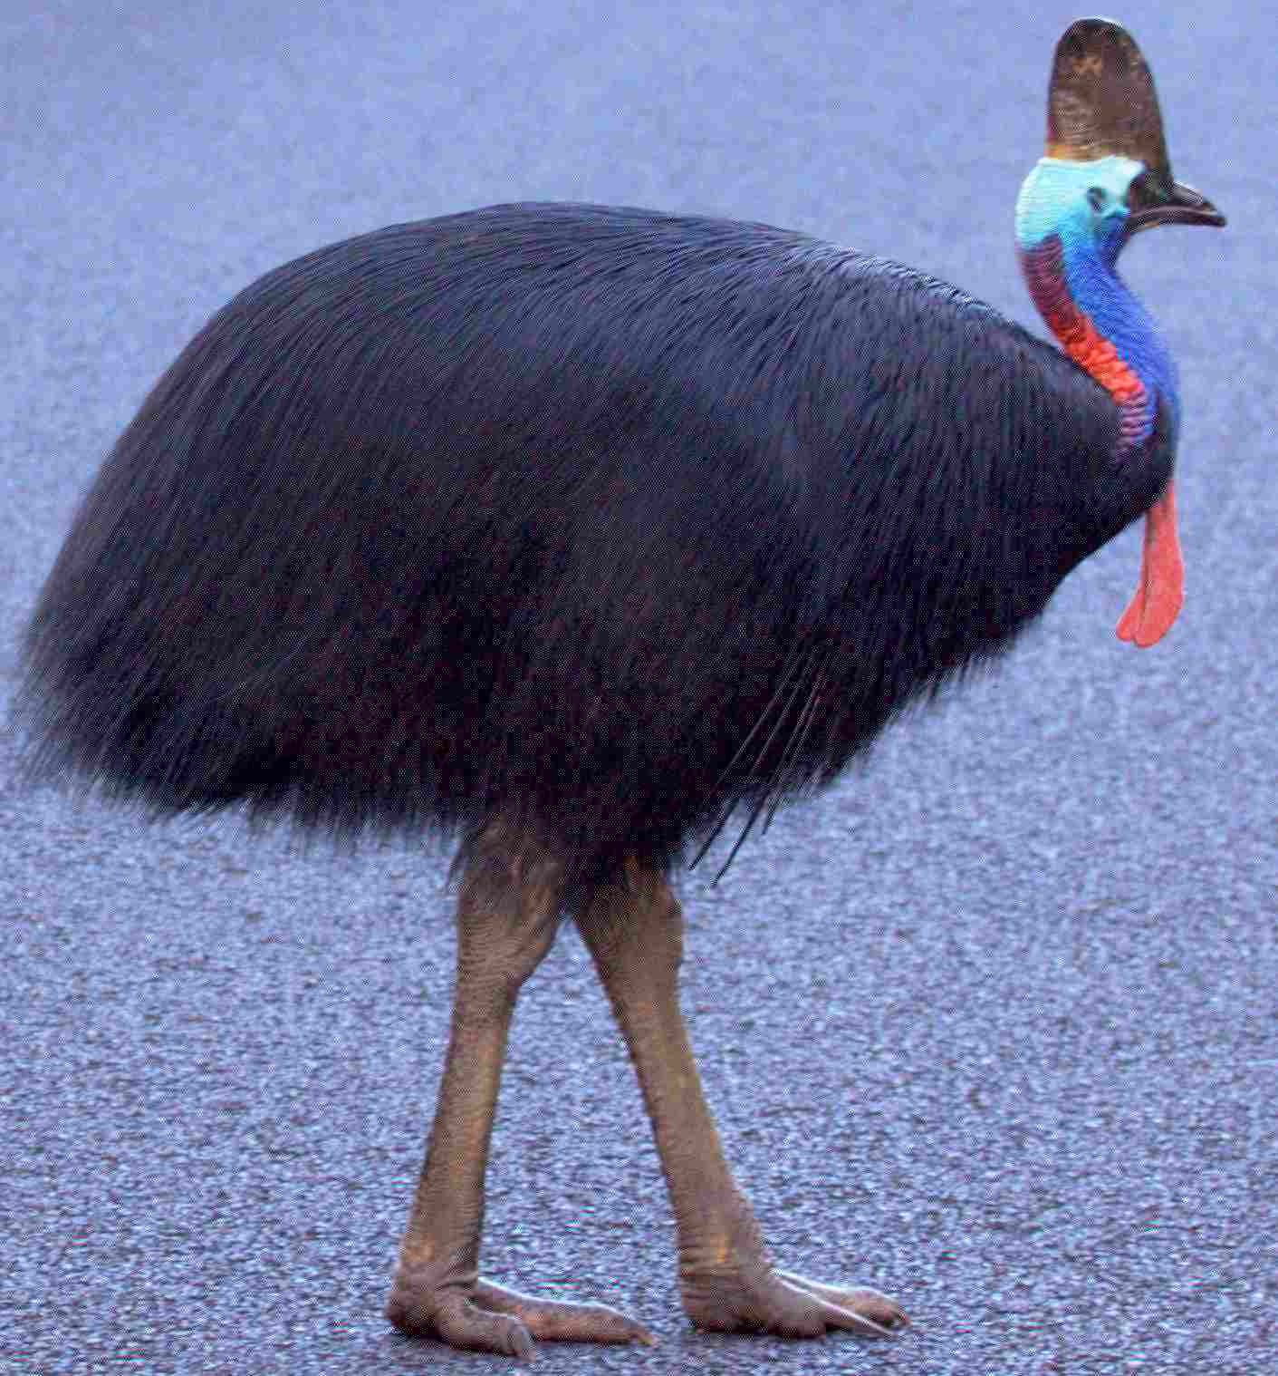
Feet: Up to 230mm long. Innermost of
the three toes is a long sharp nail
measuring up to 80mm. In defense the
cassowary will fight by leaping in the
air and kicking forward with one or
both feet.

If you are fortunate enough to encounter
a cassowary:

*Do not run away
*Stand quietly and let it pass or back off
slowly
*If bird seems aggressive stand quietly
behind a tree
*Do not chase after them
*Do not feed them

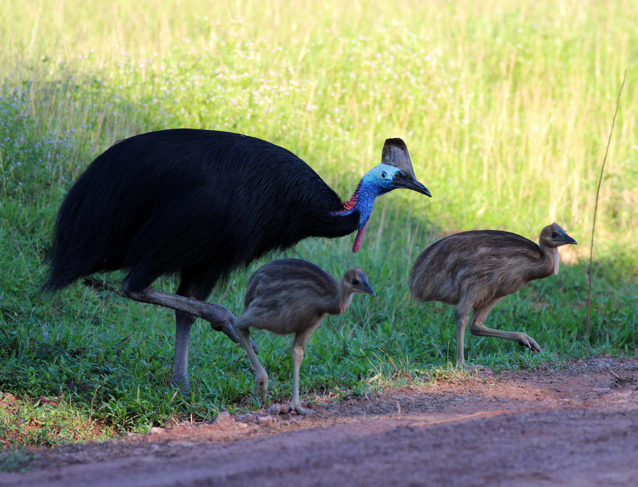
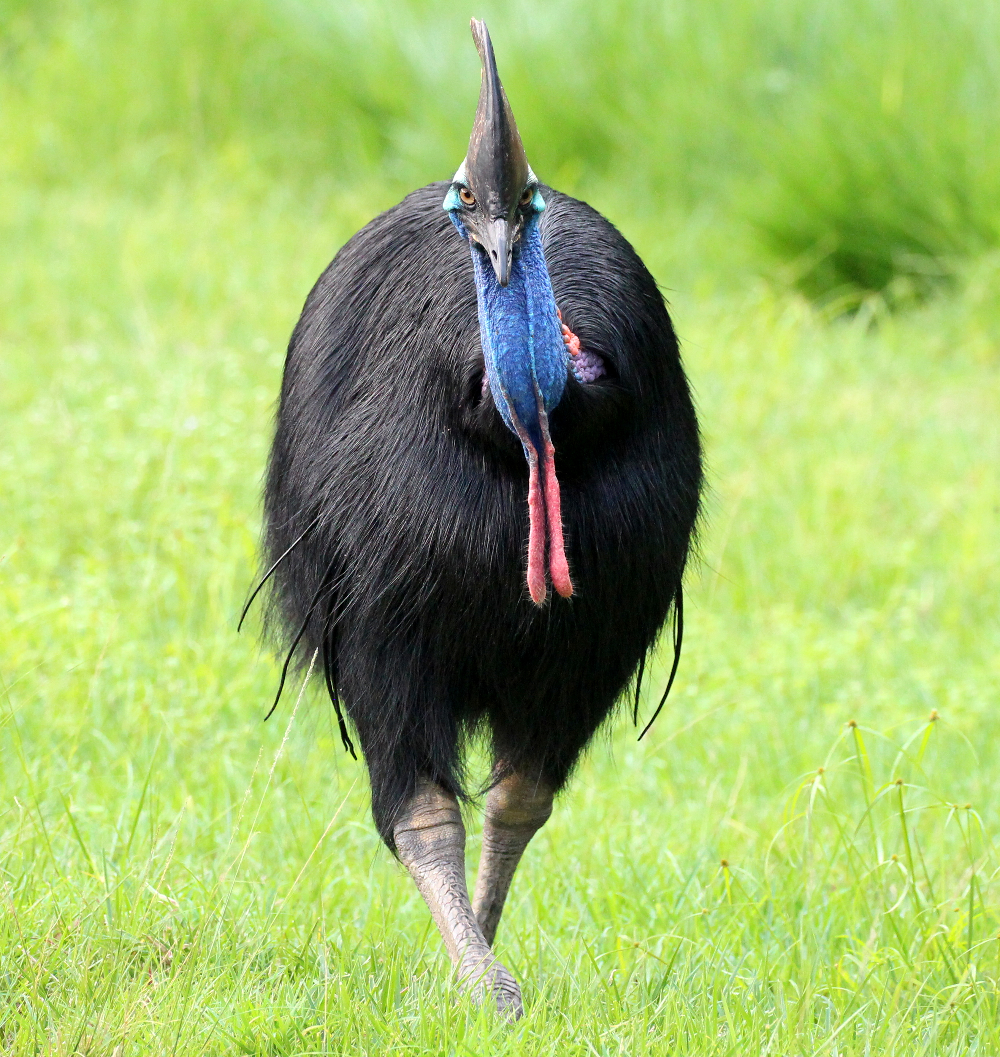
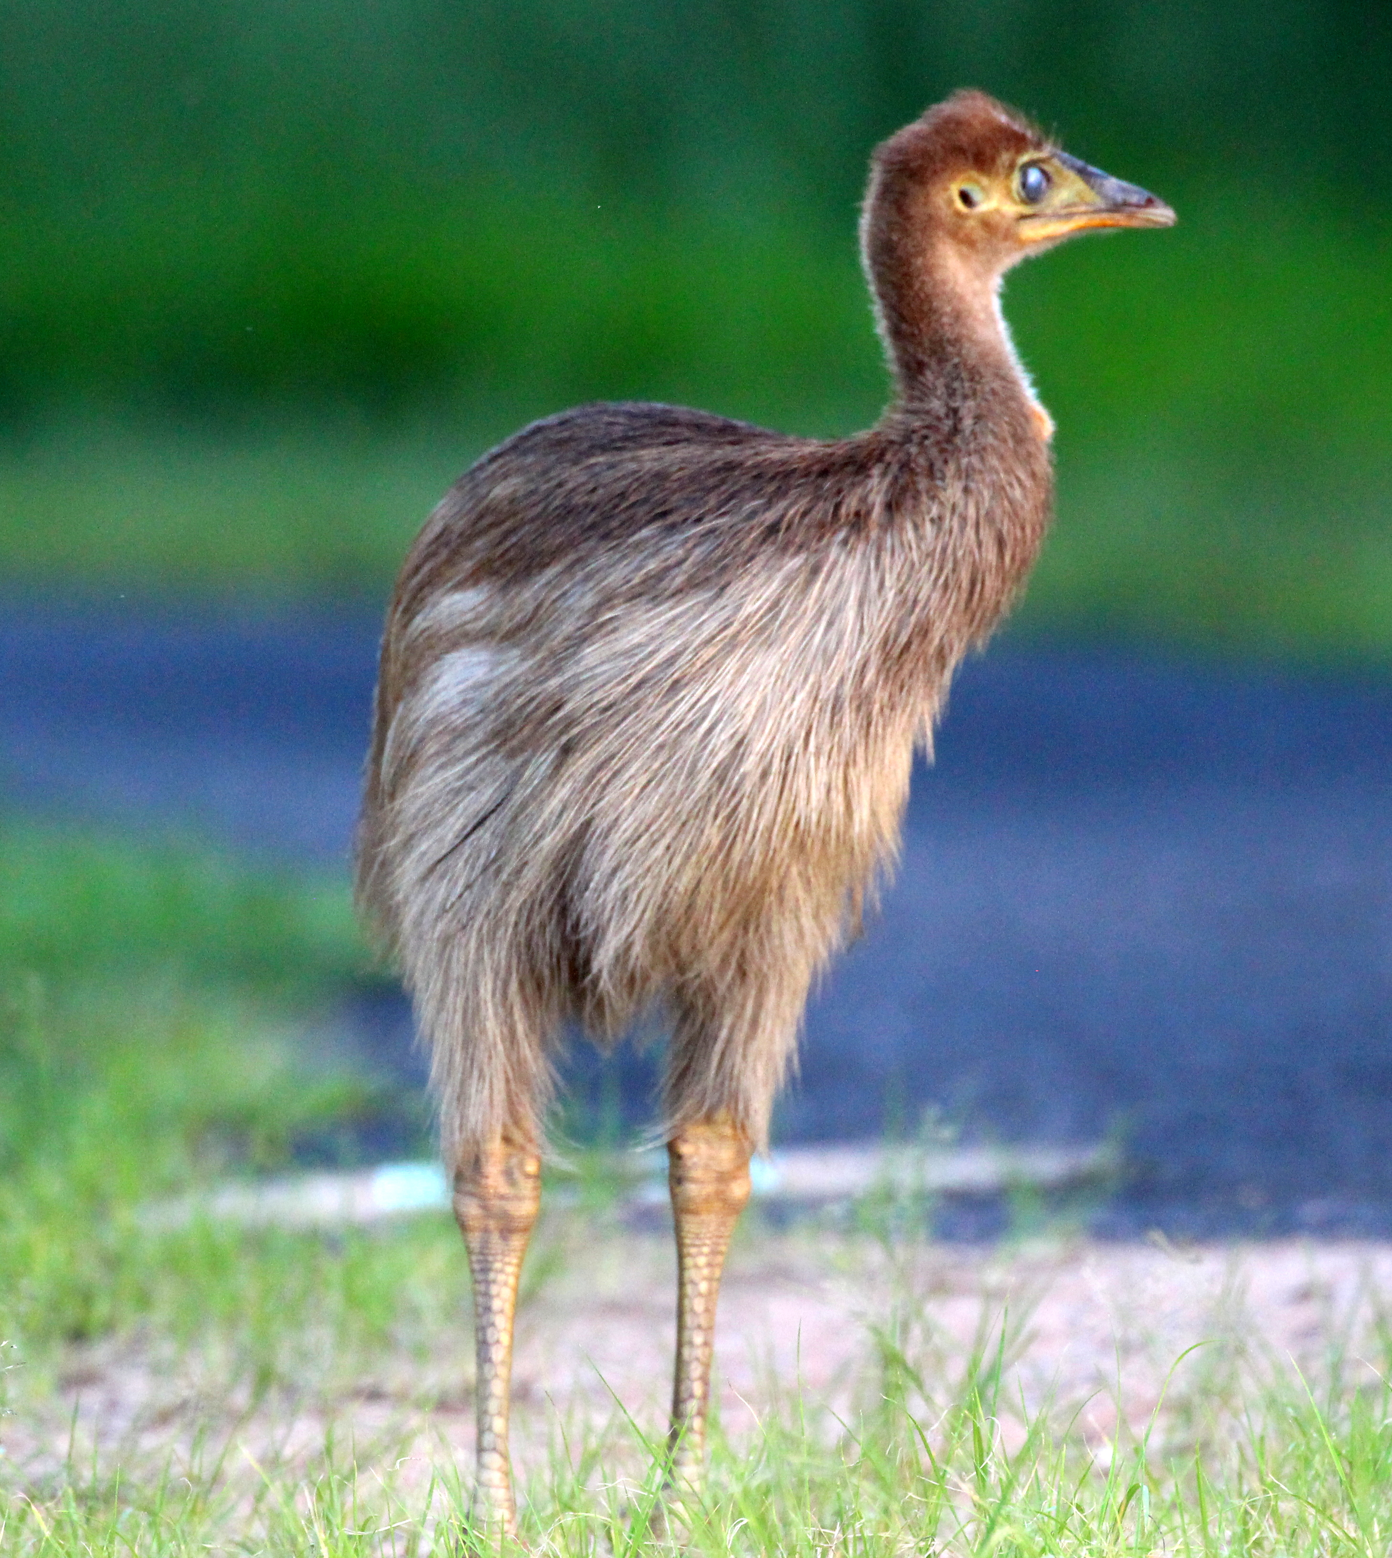
MORE CASSOWARY BITS
Cassowaries are 99% frugivores, i.e., fruit and berry eaters. 1% opportunistic feeding of snails, worms, cicadas etc. etc…and occasionally road kill.
They are diurnal spending the day foraging for food and roost at night (on the ground).
They live for at least 20+years in the wild although there are instances of a few over 50 years of age as well. Some in captivity have lived up to 64 years.
The eggs are pea green in colour and weigh 500-600 grams.
A ‘clutch’ of eggs average 3-5 and the incubation period is between 50-55 days.
CASSOWARY INFO: FAST FACTS
ADULTS:
Casque fully developed
Wattles small till 4-6 years of age
Male – 4yrs. Mature black plumage, bare face & neck. Wattles brightly pigmented. Long tail feathers. Average height 1.5mtrs. Average weight 35kgs. Incubates eggs and raises chicks for an average of 9-12 months or more.
Female – 4yrs. Mature black plumage, bare face & neck. Wattles brightly pigmented. Short tail feathers. Average height 1.8mtrs. Average weight 60kgs.

Chicks:
0-5 months: Striped plumage. In company with a male.
5-16 months: Dull brown plumage increasing in darkness. Independent of male.
SUBADULT:
7-24 months: Dull brown plumage increasing in darkness. Independent of male.
2-4 years: Plumage black with brown tips, neck and head slight colouring.

