C4 Newsletter April 2016

Welcome to the first official C4 newsletter for 2016. Apologies for the delay in communication. Not hearing from us is not an indication that nothing is happening, but instead that C4 is involved in so many time-consuming activities. This newsletter will give an update on the most important/urgent, but please visit our website (www.cassowaryconservation.asn.au) or facebook to see more.
DATES to remember
Tonight Apr 12 7.30pm – MBCA C4 theatrette
Sat 16th April, 3pm-5pm – Working-bee, Bingil Bay Reserve
Sat 23rd Apr/7th May, 5pm – C4 General Meeting, C4 Display Centre.

MBCA meeting tonight – 7.30pm at C4 theatrette. The newly-elected mayor John Kremastos will be present, so I urge Mission Beach residents to attend to show him that Mission Beach values its natural environment. The new pool, Clump Point boat ramp and dogs are all likely topics.
Mission Beach pool location – the election of a new council has encouraged the renewed push by some to build the new pool as a foreshore lagoon in the Council Caravan Park site. C4 strongly opposes this location for the obvious reason that new infrastructure should not be built in the vulnerable storm-surge zone, especially with the increasing awareness of impending sea-level changes.
Mission Beach Marine Infrastructure Project. The ‘new’ proposal by MB Boating Association for a rock island connected to the Clump Point breakwater by a bridge and incorporating expanded commercial pontoons and a barge ramp has been put forward as a ‘consensus’ alternative to the overtopping breakwater offshore of the Perry Harvey jetty. C4 does not accept that this is a viable alternative for many reasons.
A brief outline of C4’s position is (i) C4 does not want the overtopping breakwater because of its negative impact on the visual amenity of the area and the prevention of better options for improving the jetty at some time in the future (ii) commercial operations based permanently at the Clump Point boat ramp will restrict the use of the area by recreational users (see below and Jason Shearer’s letter to the TT, p4, March 31) as well as requiring major upgrading of the access road past Ecovillage. (iii) the following points have been presented to MBCA by Liz Gallie and are supported by C4
- This is essentially the same plan presented to DSDIP at the final meetings last year except for the bridge. The bridge is an attempt to overcome the requirement for there to be a realignment of the Great Barrier Reef Marine Park boundary by claiming it is not attached to the mainland.
- This design is likely to require initial and ongoing dredging.
- The reason DSDIP have not adopted any of the extensions to the existing boat ramp proposals is because GBRMPA have advised it would/could not approve the design for the above reasons.
- A new assessment process that would require a realignment of the boundary would need to be carried out on a federal government level and could take up to 8 years.
- DSDIP would not leave the remaining funds on the table for a new protracted application and assessment process for Mission Beach boating infrastructure
- Port authorities do not mix industrial with recreational and tourism marine facilities. A barge would require all other activities to cease and be sectioned off to cater for forklifts and heavy vehicles while in operation to load and unload gas bottles and skip bins any time of the day or night as the tide dictates. There would be an increase of industrial trucks through the middle of Mission Beach.
For a more detailed explanation of C4’s position and the history of the project, please visit our website which will be progressively updated.
Dogs in the Cassowary Coast Region In response to ongoing community concern about unleashed dogs and their effect on people and wildlife, CCRC have initiated a dog audit to redress (at least partially) the acknowledged problem that they don’t even know how many dogs live here, much less how they can be managed. One major concern is that there is no timely process for dealing with problem dogs after hours or on weekends.
The issue of large predatory dogs (especially ‘pig-dogs’) needs much greater community pressure considering dog-attack is recognized as one of the three main threats to cassowary survival. C4 is supporting the Cassowary Recovery Team and local Ingrid Marker in progressing this issue.
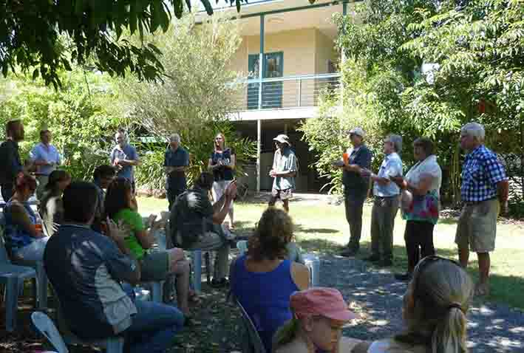
Garners Beach Cassowary Rehabilitation Centre

Carolyn Emms of Tableland-based Rainforest Reserves is to be the guest speaker at our next General Meeting, Saturday April 23/May 7 at 5pm in the C4 Theatrette.
Rainforest Reserves Australia is the successful applicant to run the Garner’s Beach Rehab Centre.
The announcement was made to a gathering at the centre last month by the Director of Wildlife Services, Lindsey Delzoppo from the Department of Environment and Heritage Protection.
RRA were selected from five applicants including C4 who lodged expressions of interest in running the centre for care of sick, injured or orphaned cassowaries.
Carolyn and Phil are former dairy farmers who bought a run-down beef farm backing onto World Heritage listed National Park near Lake Barrine. Most of the property had been previously cleared and Toohey’s Creek was choked with weeds and algae dramatically affecting the water quality.
Since then, with the help of volunteers, they have planted more than 45,000 rainforest trees. Native birds and mammals have returned and the water quality along Toohey’s Creek has improved.
They have also started building a facility to accommodate sick or injured cassowaries on the Lake Barrine property.
The Emms also own a 1.6ha property at White Rock near Cairns which they revegetated, resulting in a great increase in native bird numbers and elimination of Indian Myna birds which are still abundant on surrounding properties.
Preliminary discussions have been held about the potential involvement of C4 and the Mission Beach community in the Garner’s Beach centre.
Smith’s Gap projects C4 recently ran a Weeds and Wildlife Open Day on Old Tully Road to encourage more effective management of weeds in this important wildlife corridor. See our facebook page for more details.
C4 is continuing a project with local landholders to improve the habitat values and connectivity through the Smith’s Gap, Maria Creek, Shell Pocket and Friday Pocket area. C4 thanks Terrain NRM for funding these projects and especially Tony O’Malley for his invaluable assistance in the planning and implementation of the Open Day. Judy Murphy and Kelly Ashwood from CCRC and Kim Badcock from Biosecurity assisted landholders with weed and tree information while Nigel Tucker from Biotropica was an informative and entertaining guest speaker on the ecology of Smith’s Gap.
World Cassowary Day, September 24th The main event will be in the Daintree this year with C4 attending, but some activities to mark the occasion will be held in Mission Beach as well as a growing number of other locations around the world. Details as they become available.
The Bridge Too Far has been built by CCRC against C4’s advice. The raised boardwalk is a better option than the original proposal and will cause less interference with the habitat in this sensitive site. Now that it has been built, C4 will cooperate with the Council in getting interpretive signage to increase the value to users.
C4 Nursery Some changes to the layout mean that even when the nursery is closed, people can come and choose from a selection of plants for which information is provided. Payment for the plants can be put into the ‘Honesty box’ rather than paying the Visitor Information Centre.

